 |  |  |  | Non-Conformance Report |  |  |  |  |  |  |  |  |  |  | Project |  |  | DTNE
 |  |  |  |  |  |  |  |  |  |  |  |  |  |  | NCR No. |  |  | DTNE-NCR-014
 |  |  |  |  |  |  |  |  |  |  |  |  |  |  | NC Date |  |  | 2020-07-22
 |  |  |  |  |  |  |  |  |  |  |  |  |  |  | Critical Item |  |  |  |  | ☐Yes ☒No
Title | DTNPL FM Thermal Vacuum Test Temperature Issue
NC  Item | Item Name(Part Name) |  |  |  |  |  |  |  |  |  | DWG No. |  |  |  |  |  |  | Rev | Serial No. |  |  |  | Quantity
NC  Item |  |  |  |  |  |  |  |  |  |  | KPLO-DTNPL-SCH |  |  |  |  |  |  | 2.0 | 1012-KB-001F |  |  |  | 1
NC  Item | Next Higher Assembly |  |  |  |  |  |  |  |  |  | Procedure No. |  |  |  |  |  |  | Rev | Supplier of NC item
NC  Item | SBC PBA
NC  Item | Subsystem |  |  |  |  |  |  |  |  |  | NC observed location(Org.) |  |  |  |  |  |  | Model
NC  Item | DTNPL |  |  |  |  |  |  |  |  |  | KASI 청정실 |  |  |  |  |  |  | ☐EM ☐EQM ☐QM ☐PFM ☒FM
Sec. A - Description of Nonconformance /Ref to Documents :
NC  detected during | A1 - (Non-functional) Discrepancy  ☐Receiving Insp./Test ☐Inspection ☐Manufacturing  ☐Integration ☐Assy. Preparation ☐Alignment  ☐Other: |  |  |  |  |  |  |  |  |  |  |  |  | A2 - (Functional) Test Failure/Malfunction/Anomaly  ☐Qualification Test ☒Acceptance Test  ☐Function Test ☐Other:
Initiated by | Initiator/QA |  |  |  |  |  | Signature |  |  |  |  |  |  | Test Operator/Cognizant Engineer |  |  |  |  |  |  | Signature
Initiated by | 최재웅 |  |  |  |  |  |  |  |  |  |  |  |  | 김선구
NC  Environment | ☐Laboratory ☐Ambient Temp/Humidity ☐Acoustic Noise ☐EMC ☐Sine Vibration ☐Random Vibration  ☐Shock ☒Thermal Vacuum/Thermal Cycle (Temp.: ℉/ ℃, Pressure: ) ☐Other:
Description(5W1H)

DTNPL FM의 Thermal Vacuum Test (2020.07.20 ~ 2020.07.24) 중 Chamber 온도가 EV spec과 약간 상이함

Contract/Subsystem/Equipment Requirements Violated: ☐Yes ☒No

Sec. B - Internal MRB Dispositions /Ref to Documents:
Decisions:  DTNPL FM Thermal Vacuum Test 온도 프로파일이 KPLO Environmental Design and Test Specification (KPLO-SP-320-002)의 Acceptance Level과 약간 상이하나 Acceptance Test에 문제가 없을 것으로 판단됨  Corrective/Preventive Actions:  Other related documents(If applicable): |  |  |  |  |  |  |  |  |  |  |  |  |  |  |  |  |  |  |  |  |  | Classification  ☐Major ☒Minor  Customer Notification required  ☒Yes ☐No  Requirements Violated  ☐RFD ☒RFW ☐N/A  Doc. No:
Disposition For Discrepancy:  ☒Use As Is ☐Rework ☐Repair ☐RTV  ☐Scrap ☐Other: |  |  |  |  |  |  |  | Disposition For Test Failure/Malfunction/Anomaly:  ☐Retest ☐Re-inspect ☐SW change  ☐Other:
Cause of NC:
☐Design ☒Human Error ☐Material ☐Procedure ☐On board Software ☐Handling ☐Workmanship
☐Test Software ☐Facility/Equipment ☐Jig/Fixture ☐Test Procedure ☐Other:
Signatures |  |  | Quality |  |  | Engineering |  |  |  |  |  | Product Assurance |  |  |  | Project Manager
Name / Signature
Date
☐ Sec. C1 – Customer held MRB  MRB No.: |  |  |  |  |  |  |  |  | ☐ Sec. C2 – Customer invited MRB |  |  |  |  |  |  |  |  |  |  |  |  | Sec. D – Closeout
Decision:  Disposition:  ☐Use As Is ☐Rework ☐Repair ☐RTV ☐Scrap  ☐Retest ☐Re-inspect ☐SW change ☐Other:  Corrective/Preventive Actions: |  |  |  |  |  |  |  |  |  |  |  |  |  |  |  |  |  |  |  |  |  | PA Name/Signature:  Date:
Signatures |  | Quality |  |  | Engineering |  |  |  |  | PA |  |  | PM |  |  |  | Customer
Org.
Name/Signature
Date

 | Non-Conformance Report | Project | DTNE
 | Non-Conformance Report | NCR No. | DTNE-NCR-014
 | Non-Conformance Report | NC Date | 2020-07-22
 | Non-Conformance Report | Critical Item |  | ☐Yes ☒No
(Continuation Sheet for Any Additional Information and Actions with clear link to the NCR)

- Description
  - KASI에서 진행한 DTNPL FM Thermal Vacuum Test 중 Chamber의 온도가 DTNPL의 EV spec과 다소 상이함을 확인
    - 1st Cold Soak 온도 ($T_{N}$)가 더 낮게 내려감 (DTNPL FM은 OFF 상태임)
    - S/B : -35ºC
    - Was : -39ºC

  - DTNPL Thermal Vacuum Test Temperature Cycling EV spec

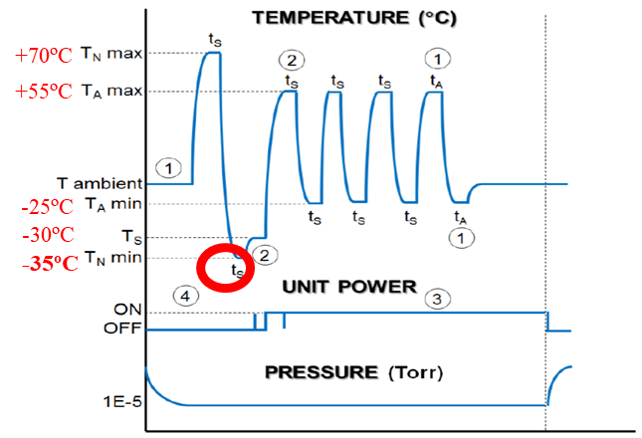

  - DTNPL Thermal Vacuum Test 수행된 온도 프로파일 (Kelvin 단위)
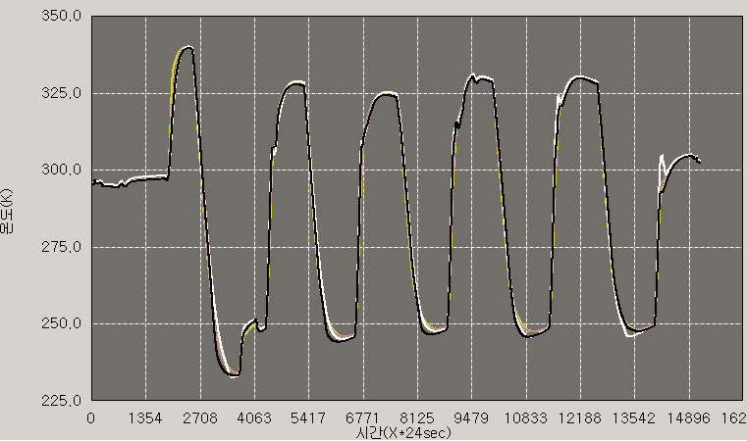

- Root cause
  - KASI Chamber Operator의 Chamber Control 미흡으로 인한 Human Error 발생

- Decision 제안
  - 현상태 진행 (use as is)
    - Thermal Vacuum Test의 온도 프로파일이 DTNPL EV spec과 일부 상이한 부분이 있지만, Acceptance Test와 DTNPL의 기능에 영향이 없는 것으로 판단되어 Waiver 요청
    - DTNPL에서 사용하는 부품의 온도 정보를 별도 제출 (부품의 Storage Temperature 재확인)

